84.05.20
From Thomas Josephson
RB MSS M1, Library, Royal Botanic Gardens Melbourne.

Pulpulla Cobar
May 20th 1884
Sir
Knowing the interest you take in these matters, I enclose you a specimen, leaves?, seed vessels, & stalk, of a plant I found here. It is a climber and I have only seen two specimens of it on this run. I also send a sprig of a plant growing beside it, not a creeper which may probably be poisonous for sheep, as it contains a very acrid sap. I shall be glad to have your opinion on the matter
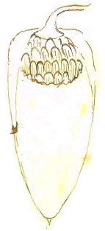
There appears to me to be another creeper here allied to that of which I send you a specimen bearing a large pod with seeds having a silky down attached. I have been accustomed to eat this pod in its green state.
I am
Yours truly
Thos. F. Josephson

P.S. I find what I mistook for leaves are only the open seed pod.

The Baron Von Müeller
Melbourne

MS found with a specimen of Sarcostemma viminale (MEL 113694). MS annotation by M: 'Answ 25/5/84'. Letter not found.
NSW.
There is a sketch inserted at this point: 84-05-20_image01.jpg

